Blog template
----------------------------------

We've partnered with Texthelp to empower our neurodiverse workforce with inclusive technology
Our employees are enjoying the benefits of our recent partnership with Texthelp, inclusive technology specialists and creators of Read&Write for Work. Read&Write is an inclusion tool that supports people who think, learn and work differently. We’ve made it available to our staff to help our neurodiverse workforce to thrive.
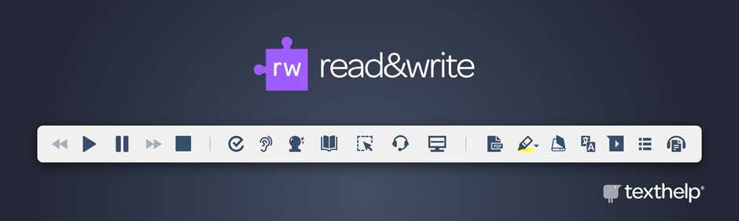
Download image
(Suggested image alt text: Read&Write logo with the Read&Write toolbar)

Used by 40 million people worldwide, Read&Write is a powerful set of reading and writing tools that make digital text easier to understand, for everyone. Its features empower all employees to understand and communicate in the way that they prefer.
Our employees can:

Communicate with confidence
With Read&Write our employees can choose to dictate information rather than type. Intuitive writing features, proofreading tools and concentration features also improve the quality of written work.
Download image
(Suggested alt text: Megaphone, email and speech bubble icons)
Choose how to understand information
Read&Write’s features enable employees to hear content read aloud, even when on-the-move. Hearing text read aloud reinforces understanding, increases focus and improves retention. It also offers a powerful proofreading tool that amplifies literacy errors.
Download image
(Suggested alt text: Sight and hearing accessibility icons)
Collate and summarize information with ease
Organisational features allow our employees to collect and summarize large amounts of information quickly, easily, and in their own way.

Download image
(Suggested alt text: Checklist with a tick icon)

Read&Write particularly benefits neurodivergent employees. For example employees with Dyslexia, Dyspraxia, Autism, and ADHD. As many as 1 in 5 people are neurodivergent, and despite their unique strengths and talents 76% don’t disclose their neurodiversity at work. With Read&Write, we’re offering instant and discreet support to all staff, without the need for anyone to self-identify. Its features help to improve focus and concentration, provide support in information processing, and offer reassurance in written communications.
It also offers powerful benefits for all employees, including those with:
- Low literacy. 54% of US adults are reading below 6th grade level. As many as 1 in 4 UK adults experience challenges due to low literacy skills. Over 40% of Australians have literacy levels below what is considered enough to get by in everyday life.
- English as a Second Language. In the US, 67 million speak English as a Second language. In the UK, nearly 8% of people speak English as a Second language. In Australia, nearly 1 million say that they speak English not well or not at all.
- Conditions that affect reading and writing. For example, those that may cause visual disturbances or difficulty with working memory. As well as conditions that cause fatigue, that may be impacted further by mental activities.

Read&Write allows 100% of our employees to learn and work in the style that suits them best. From the visual learners, auditory processors and verbal communicators. To the organised researchers, logical analyzers, detail-oriented, and beyond.
Download image
(Suggested image alt text: Read&Write toolbar)

Key features include;
- Text-to-speech support, which is not only perfect for the auditory processor, but also provides a convenient alternative to visual proofreading, helping to amplify literacy errors for employees with Dyslexia;
- A grammar, spelling and homophones checker, known as Check It, which helps to reduce writing errors;
- Dictation which allows employees to complete written work with the spoken word;
- A prediction feature which intuitively predicts the word that’s being typed and the word most likely to follow, so staff can maintain their focus and flow;
- A Screen mask overlay which tints the whole screen in any chosen color, and helps to reduce visual stress and distraction. It also provides a reading spotlight which improves focus;
- And, colourful collectable highlighters which employees can use to summarize information quickly and easily. They can also highlight and collect digital content from multiple sources into one document, with automatic source referencing.
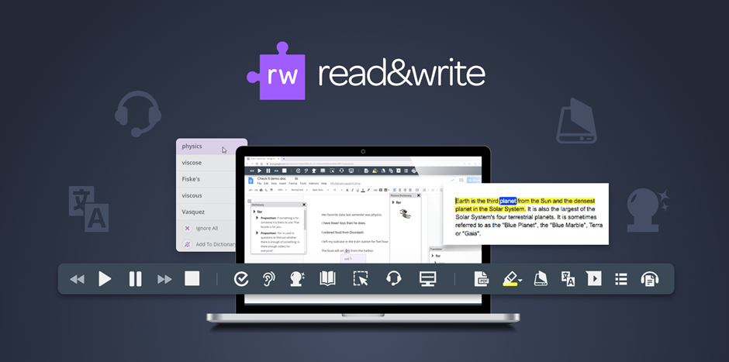

Download image
(Suggested image alt text: Read&Write logo with the Read&Write toolbar open on screen with the text-to-speech tool in action)

And, the integration process is seamless!
Read&Write for Work can be integrated across any platform, and with the software comes a team of experts to ensure a seamless integration process. Our employees were up and running with the software in no time, and the team at Texthelp have been with us every step of the way, providing us with all the support and guidance we need to make best use of the software.
To find out more about Read&Write for Work, visit our partner, Texthelp, at text.help/read-write-for-work.

