ReachDeck blog announcement to customers:

We’ve added speech, reading and translation support to our website with ReachDeck

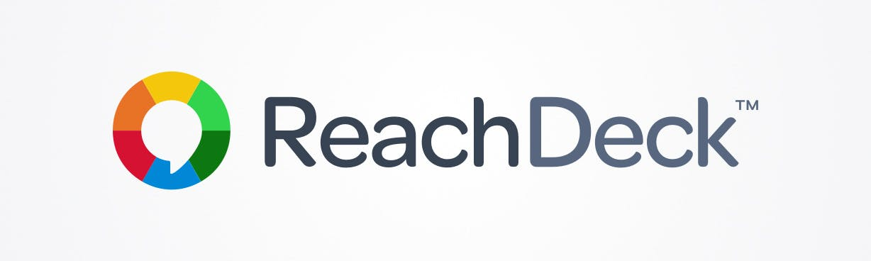
Download image
(Image alt text: ReachDeck logo on a white background)

We’re pleased to announce that we’ve added speech, reading and translation support to our website with ReachDeck. More specifically, the ReachDeck Toolbar.

ReachDeck is a tool from Texthelp. It helps us to make our online content more available to everyone. The ReachDeck Toolbar is one of three ways it does this.

The ReachDeck Toolbar offers our visitors assistive features. Giving them a choice in how they access our online information.

But, why is this important?
Globally 1 in 7 people have a disability. For many, they experience barriers when they’re on the web. For example, people with visual impairments might struggle if information is only available in text format. And those with cognitive disabilities might find it difficult to read information on a crowded web page. This can impact their ability to browse, buy and access online content or services. What's more, only 1 in 10 people in need have access to assistive technology. By adding the ReachDeck Toolbar, we're giving extra support to people that might need it.
Our visitors can choose to have our content read out loud. They can remove distracting content, or add a screen tint with a reading pane to help them focus. They can translate our web pages into over 100 languages. And much more!

Try it out for yourself
Can you see the orange launchpad on your screen [edit to suit your integration]? Click it to launch the ReachDeck Toolbar. To hear text read out loud, simply click on the first icon and hover your mouse over any text. From a touchscreen device you’ll have to click on the text to hear it.
Now, apply a screen tint by clicking on the eye icon. To explore more, click on the question mark (?) icon to discover what each feature on the toolbar does.

Download image
(Image alt text: ReachDeck Toolbar with features including Text-to-Speech, Text Magnifier and Screen Mask)

ReachDeck supports our goal for the future
We want to do our part to create a digital world that’s welcoming to everyone. As well as giving our visitors support tools, ReachDeck supports our goals by:

- Helping us to write content that’s easier to understand. The ReachDeck Editor gives our staff a tool to make sure that what they write is simple and clear. It helps them to improve the readability of all their content.
- Helping us to discover accessibility problems quickly. The ReachDeck Auditor scans our site for technical WCAG errors and readability errors. So that we can fix and remove accessibility barriers with ease.

For more information on ReachDeck, visit: https://www.texthelp.com/products/reachdeck/
If you’d like to give feedback on ReachDeck, the team at Texthelp would love to hear from you.

